DES RESSOURCES POUR LE PROJET FINAL
LE PASSÉ COMPOSÉ ET L’IMPARFAIT
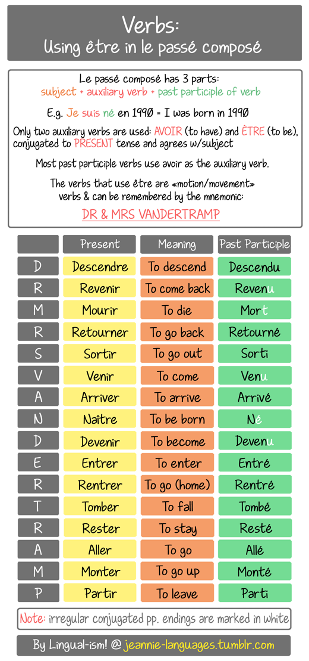
VERBES UTILES
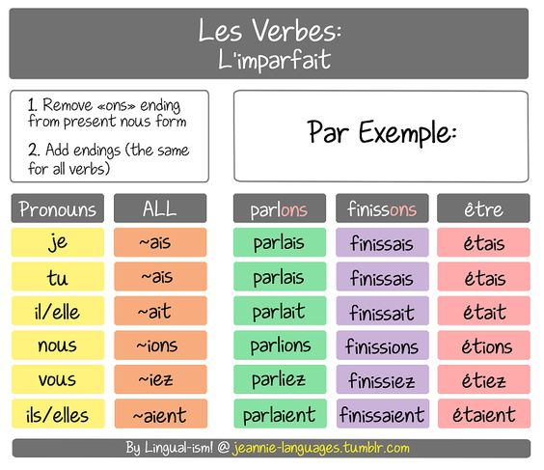
IMPARFAIT
PC AVEC ETRE
PC AVEC AVOIR
être | to be; being | voir | to see | falloir | it is necessary, must, have to
avoir | to have | devoir | to have to, must; duty, test | passer | to pass, go by, cross
aller | to go | venir | to come, occur | penser | to think
faire | to do, make | suivre | to follow | attendre | to wait for, expect
dire | to say, tell | parler | to speak, talk | trouver | to find
pouvoir | can, to be able to | prendre | to take, get | laisser | to leave
vouloir | to want | croire | to believe, think | arriver | to arrive
savoir | to know | aimer | to love, like, be fond of | donner | to give, give away
regarder | to look at, watch | rester | to stay, remain | comprendre | to understand
appeler | to call, ring | arrêter | to stop | sortir | to go out; take out
partir | to go, leave, go away | connaître | to know, experience | entendre | to hear, listen to, understand
mettre | to put, put on, wear | demander | to ask, ask for, be looking for | chercher | to look for, seek
aider | to help, aid | revenir | to come back, return | finir | to finish, end
essayer | to try, try out, test | perdre | to lose, miss | sentir | to smell, sniff, feel
jouer | to play | rentrer | to bring in, take in; to get in, go in, come home | vivre | to live, be alive, go through
rendre | to return, give back, repay | tenir | to hold, run, keep, last | oublier | to forget, miss
travailler | to work, work on, practice | manger | to eat | entrer | to go in, enter, come in
devenir | to become | commencer | to start, begin | payer | to pay
tirer | to pull, draw | ouvrir | to open | changer | to change, exchange
excuser | to forgive, pardon, excuse | dormir | to sleep; to lie idle | occuper | to occupy, live in, take up
marcher | to walk, march, go | envoyer | to send, throw, dispatch, refer | apprendre | to learn, to hear (about)
boire | to drink (consume alcohol), to soak up | garder | to keep, to look after, to guard | montrer | to show, point out
asseoir | to sit down, sit up | porter | to carry, wear | prier | to pray
servir | to serve | écrire | to write | retrouver | to find; to meet
VERBES UTILES
gagner | to win, earn | acheter | to buy | rappeler | to remind, remember, call back, be reminiscent of
lire | to read | monter | to go up, rise, come up | quitter | to leave, depart
emmener | to take (somebody), take along | toucher | to touch | continuer | to continue
raconter | to tell | répondre | to answer, reply | sauver | to save
rencontrer | to meet, encounter | fermer | to close, shut | valoir | to hold, apply; to be worth
compter | to count | bouger | to move | apporter | to bring, supply
décider | to decide | vendre | to sell | expliquer | to explain, account for
agir | to act, behave; work, take effect | adorer | to adore, love | recevoir | to receive, to get
utiliser | to use | coucher | to put to bed, lay down, to sleep | préférer | to prefer
offrir | to offer, give | préparer | to prepare, make, get ready | choisir | to choose
conduire | to drive, lead | chanter | to sing | présenter | to introduce, present
accepter | to accept | refuser | to refuse, turn down | terminer | to end, finish
amuser | to amuse, entertain | intéresser | to interest | Rire | to laugh, have fun, joke
pardonner | to forgive, pardon, excuse | embrasser | to kiss; to embrace, encompass | danser | to dance
détester | to hate, detest | maintenir | to keep, maintain | supposer | to suppose, assume
épouser | to marry, to espouse | approcher | to approach | craindre | to fear, to be afraid of
crier | to shout | inviter | to invite | arranger | to arrange, to organize
remercier | to thank | répéter | to repeat; to go over, rehearse | signer | to sign
accompagner | to go with, accompany | oser | to dare | permettre | allow
annuler | cancel | laver | clean | se plaindre | complain
faire du mal | hurt | avoir besoin | to have | épeler | to spell
traduire | translate | éteindre | turn off | allumer | turn on

VERBES UTILES
se réveiller | wake up | ajouter | to add | goûter | to taste
coûter | to cost | cuire | to cook | décrire | to describe
effacer | to erase | enseigner | to teach | nettoyer | to clean
noter | to write down | reconnaître | to recognize | remplacer | to replace
visiter | to visit | souhaiter | to wish | tomber | to fall
acclamer | to cheer, acclaim | accorder | to admit | accourir | to hurry
accrocher | to hang (up) | accueillir | to welcome | acquérir | to acquire
adjoindre | to appoint | admirer | to admire | annoncer | to announce
arracher | to pull up/out | augmenter | to increase | avoir raison | to be right
blaguer | to joke | causer | to chat, cause | cheminer | to walk on
confondre | to confuse | conseiller | to recommend | dépenser | to spend
emprunter | to borrow | s’endormir | to fall asleep | éviter | to avoid
féliciter | to congratulate | geindre | to groan | informer | to inform
nommer | to name | louer | to rent | ressentir | to feel
secouer | to shake | soutenir | to support | jurer | to swear, vow
méprendre | to mistake | mélanger | to mix | apprendre par coeur | to memorize
reconduire | to renew | rejeter | to reject | gérer | to manage
refléter | to reflect | presser | to squeeze | répandre | to spread
frapper | to knock | remettre | to put back (on) | revêtir | to put on
enregistrer | to record | pêcher | to fish | rougir | to redden
tousser | to cough | pleurer | to cry
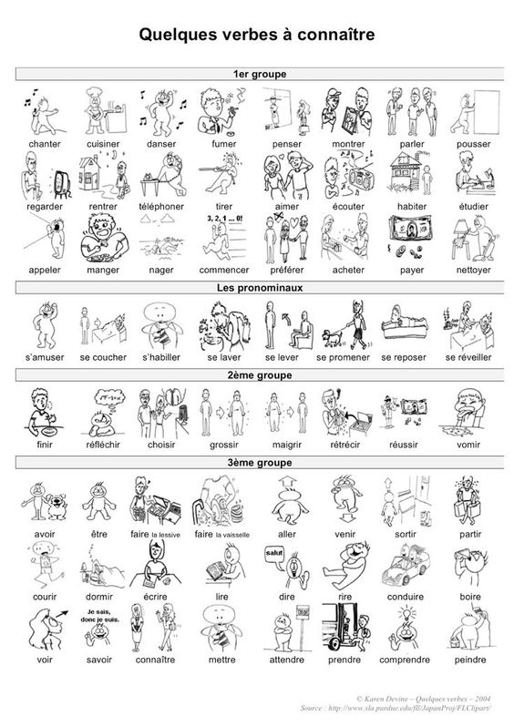

LES PRÉPOSITIONS

