Visas

_____________________________
Visas

1.
2.
3.

_____________________________
_______
1.
2.
3.
_______
_____________________________
_____________________________
_____________________________
_____________________________
_____________________________
_____________________________
1.
2.
3.

_______
1.
2.
3.

_______
_______
1.
2.
3.
_______
1.
2.
3.
1.
2.
3.
_______
1.
2.
3.
_______
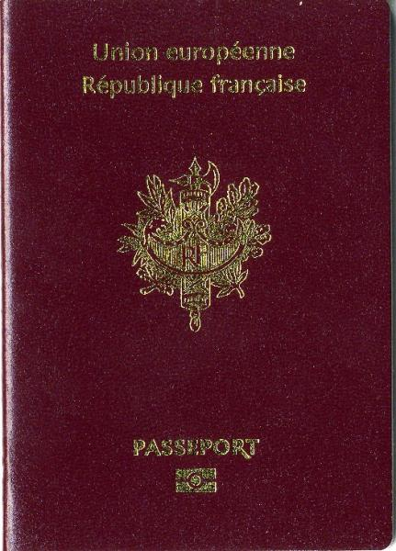
Ma décision est prise!
Décrivez quelle ville vous aimeriez visiter et les 3 choses que vous avez indiqué dans ce passeport. Expliquez pourquoi vous avez choisi cette ville et pourquoi vous voulez la visiter.
______________________________________________________________________________________________________________________________________________________________________________________________________________________________________________________________________________________________________________________________________________________________________________________________________________________________________________________________________________________________________________________________________________________________________________________________________________________________________________________________________________________________________________________________________________________________________________________________________________________________________________________________________________________________________________________________________________________________________________________________________________________________________________________________________________________________

Ce passeport appartient à:_______________________________________
Avec ce passeport, vous allez visiter 8 villes. Écrivez le nom de la ville sur la grande ligne et puis indiquez 3 choses que vous aimez le plus de chaque ville. Chaque ville que vous visitez doit parapher (initial) sur la petite ligne.

