La Musique: Vocabulaire et Activités /75

LE VOCABULAIRE

Les Instruments  Français Anglais |  | Les Genres  Français Anglais

Les Personnes  Français Anglais |  | Les Verbes  Français Anglais
le compositeur | composer | jouer | to play
le musicien(ne) | musician | écouter | to listen
le chanteur/la chanteuse | singer | chanter | to sing
Le rappeur/la rappeuse | rapper | composer | to compose
l’artiste | artist | enregistrer | to record

Les Déscriptions  Français Anglais |  | Les Autres Mots Utiles  Français Anglais
rapide | fast | les paroles | lyrics
lent(e) | slow | le rhythme | rhythm
fort(e) | loud | l’album | album
doux (douce) | quiet | la tournée | tour
calme | calm | les morceaux | pieces/songs
énervant(e) | irritating
énergetique | energetic
dramatique | dramatic

LES ACTIVITÉS

A. Interpretive Reading Task (6 pts)
Read the infograph and answer the below questions in English.
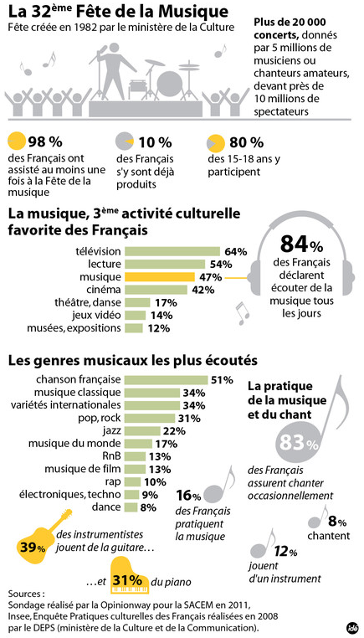
- What percentage of French people listen to music every day?
- What are the most and least listened to genres of music?
- What percentage of French people play a musical instrument?
- What percentage of people who play a musical instrument play the guitar?
- What do you think La Fête de la Musique is? Is it popular?
B. Interpretive Listening Task (9 pts)
Listen to the interviews regarding music and answer the below questions in English.

A. Watch this interview with Belgian artist Stromae: https://www.youtube.com/watch?v=4Y5-kIIdfm0
Identify 5 French words/terms you heard that are associated with music.

B. Watch this interview between 2 French teenagers: https://www.youtube.com/watch?v=SoEzLpuhoCw
- What types of music does the singer perform?

- Identify 4 other French words/terms you heard that are associated with music.

C. Interpersonal Speaking Task (10 pts)
With a partner, discuss your favorite song in French.
(Alert teacher before you have conversation, then ask her to initial here once you finish _____ )

Be sure to include the following:
- The title of the song and the artist
- The genre of music
- A description of the song
- Why you like the song

I had my interpersonal conversation with _________________ on ____________(date).

My favorite song is ____________________________ by ______________________.

My friend’s favorite song is ________________________by _____________________.

I described my song as:

My friend described his/her song as:

D. Interpretive Reading Task (5 pts)
Read the article about Claude Debussy and answer the below questions in English.

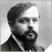  ©Roger-Viollet | Musiciens - France  Claude Debussy  Musicien (22/08/1862 - 25/03/1918)
Claude Debussy
Né à Saint-Germain-en-Laye (France) le 22/08/1862
Mort à Paris (France) le 25/03/1918

Achille-Claude Debussy naît l'aîné d'une famille modeste. Il se passionne très tôt pour la musique et rencontre par chance une ancienne élève de Chopin, qui accepte de lui donner des cours de piano. Grâce à ce professeur particulier, il est accepté au Conservatoire en 1872. Le premier prix de Rome en poche, il accomplit de nombreux voyages en compagnie de Mme von Meck, qui lui présente les meilleurs compositeur (Brahms, Wagner). En 1902, il présente son opéra "Pelleas et Mélisandre", oeuvre retentissante de sa carrière. Chacune de ses compositions symphoniques ou pour piano relève d'une originalité frappante qui s'applique à l'harmonie et aux rythmes.

- What kind of music lessons did Debussy take?

- What type of artist was Debussy?

- For what was his music known?

- For what instruments were his pieces written?

- What is his most well-known piece titled?

E. Interpretive Listening Task (10 pts)
Listen to the song Champs Elysée and fill in the missing French lyrics. Then answer the
reflection questions in English. https://www.youtube.com/watch?v=OAMuNfs89yE

Aux Champs Elysées par Joe Dassin
Je me baladais sur l'avenue le coeur ouvert à l'inconnu
J'_________________ envie de dire bonjour à n'importe qui
N'importe qui et ce fut toi, je t'ai dit n'importe quoi
Il suffisait de te ___________, pour t'apprivoiser

Aux Champs-Elysées, _____________ Champs-Elysées
Au soleil, sous la pluie, à midi ou à minuit
Il y a tout ce que vous voulez ____________ Champs-Elysées

Tu m’________________________ "J'ai rendez-vous dans un sous-sol avec des fous
Qui vivent la ___________ à la main, du soir au matin"
Alors je t'ai accompagnée, on _______________________, on ____________________
Et l'on n'a même pas pensé à s'embrasser

______________ Champs-Elysées, aux Champs-Elysées
___________ soleil, sous la pluie, à midi ou à minuit
Il y a tout ce que vous voulez aux Champs-Elysées

Hier soir deux inconnus et ce matin sur l'avenue
Deux amoureux tout étourdis par la longue nuit
Et de l'Étoile à la Concorde, un ____________________ à mille cordes
____________ les oiseaux du point du jour ___________ l'amour

Aux Champs-Elysées, aux Champs-Elysées
Au soleil, sous la pluie, à midi ou à minuit
Il y a ________________ ce que vous voulez aux Champs-Elysées

Questions (answer in English):
- What genre is this song?
- How would you describe this song?
- What is the Champs-Elysées?
- What is there on the Champs-Elysées?
- When is a good time to go to the Champs-Elysées?
- What are 2 things the couple in this song did in the past?
F. Interpersonal Speaking Task (in French) (10 pts)
Create your own song (3-4 boxes long) on http://eng.musicshake.com/create/ and give it a French title. Share your piece with your partner and discuss both of your creations. (Alert teacher before you have conversation, then ask her to initial here once you finish _____ )

In French, ask each other the following questions:
- What is title of your French song?
- What instruments did you use in your song?
- Why did you choose those instruments for your piece?
- How would you describe your piece?
I had my interpersonal conversation with _________________ on ____________(date).
The title of my friend’s piece:
The instruments my friend used in his/her piece:
Why my friend chose these instruments:
How my friend described his/her piece as:

G. Interpretive Reading Task (5 pts)
Look at the iTunes playlist and answer the below questions in English or French.
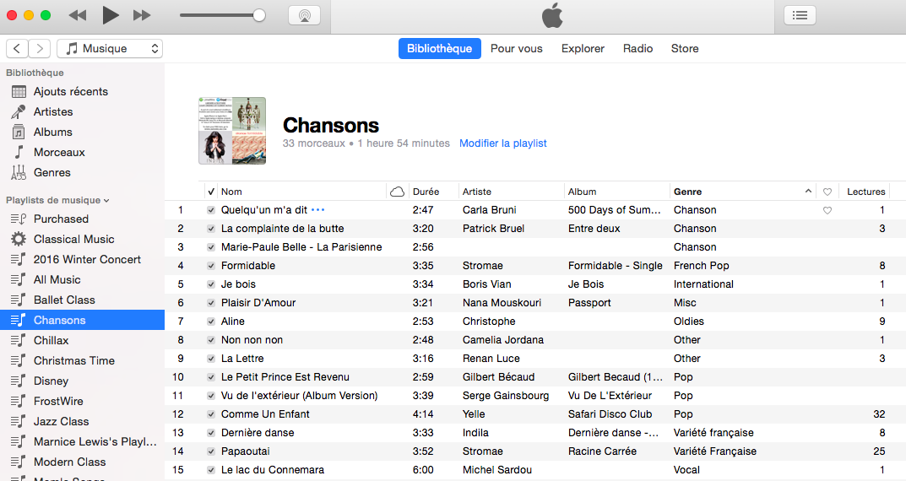
- What column would I look under to find the length of the song?
- What is the favorite song of this listener? How can you tell?
- What artist sings Non non non?
- What genre of music is Yelle’s song and what’s its title?
- How many songs are in this playlist (it is not 15)?
H. Presentational Writing Task (20 pts)
Choose one of the following songs that were played in class and write, in French, about one of them.
Classical - Debussy - https://www.youtube.com/watch?v=FoD_AxKoJDs
Hiphop - Maitre Gims - https://www.youtube.com/watch?v=KA3Q1duzwaE
Folk - En Roulant Me Boule - https://www.youtube.com/watch?v=aeV4S8-7HJc
Rap - OR - https://www.youtube.com/watch?v=Chpdrh2Gniw
60s - Michel Sardou - https://www.youtube.com/watch?v=IYINRTN4YNQ
Rock - Yelle - https://www.youtube.com/watch?v=5c-GeBqUgAA

Be sure to include the following information:
- The title of the song and the artist
- The genre of music
- A description of the music
- How it made you feel
- The instruments you heard
- The people involved in creating the song

