1. **USAGE**

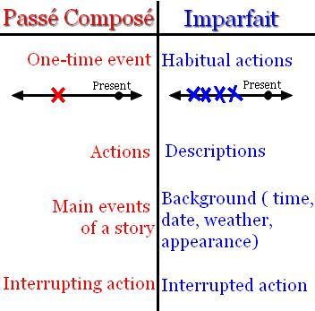

1. **FORMATION**

Formation :

_______________________ + ________________________

Stem formation:

________________form of the verb’s present tense

endings:

je _______________ nous _______________

tu_______________ vous _______________

il/elle/on ________ ils/elles _______________

Only entirely irregular verb in imparfait : ____________

Stem = ___________

