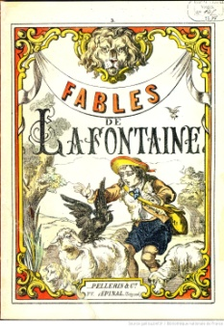
Les Fables
de Payton

Contenu – Entirely in French
Texte
- 6 words or expressions from chapter 1.1 (p. 6-9), /6
  - correct gender, article, spelling

- 8 words or expressions from chapter 1.2 (p. 18-21) /8
  - correct gender, article, spelling

- 5 verbs (p. 22, 24, 26), correct usage and formation /5

- 3 adjectives (p. 12, 14), correct agreement and placement /3

- each of the above underlined or highlighted in a different color /3

Lesson or moral is clear and makes sense /10

Overall French usage /10

CONTENU /45

Style
- Cover and title /3

- Visual for each action/idea that illustrates the text /5

- Organized, legible, neatly done /5

- Overall creativity/effort /7

STYLE /20

TOTAL /65

